**On jenkins Master:**

As root

useradd user1

passwd user1

___________________

**On jenkins linux slave:**

As root

useradd user1

passwd user1

**On both jenkins master and slave:**

vim /etc/ssh/sshd_config

change Pass auth to yes

vim /etc/sudoers---add below line

user1 ALL=NOPASSWD: ALL

systemctl restart sshd--do these on both the machines

**On jenkins master;**

Su - user1

Ssh-keygen

Ssh-copy-id -i user1@ipofslave

Ssh ipofslave

exit

Ssh connection established .

**On jenkins dashboard:**

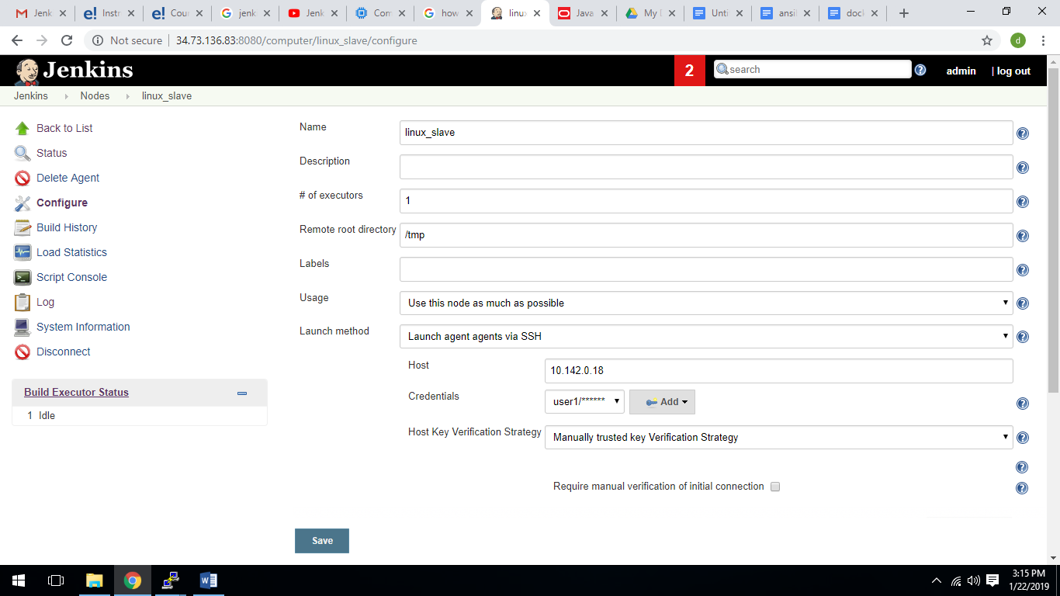

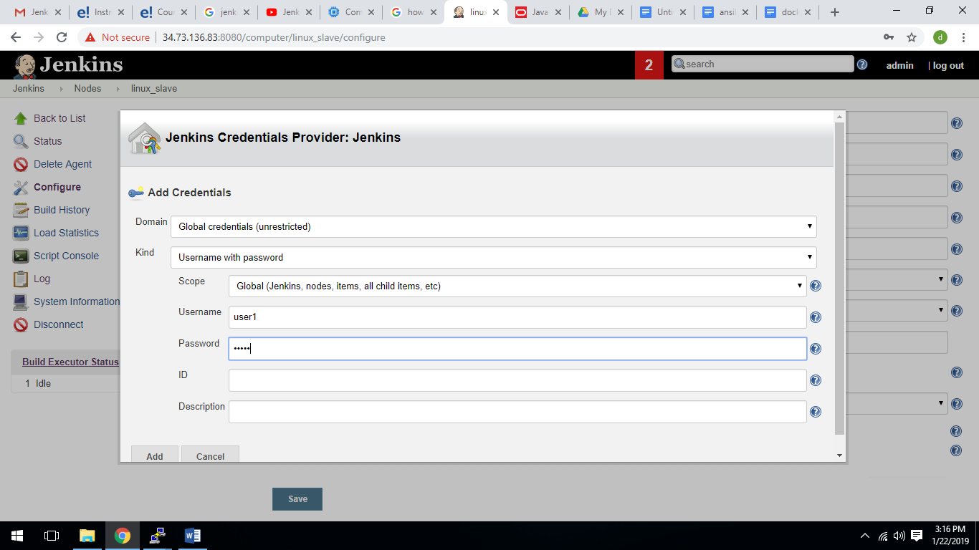

Install java on linux slave:(yum install java-1.8.0-openjdk)

Then launch the agent

